Physical Science Plus

CONVECTION & CONDUCTION
TRANSFER OF ENERGY THROUGH WAVES
FEATURES OF WAVES
TRANSMISSION OF SOUND
THE ELECTROMMAGNETIC SPECTRUM
ABSOPRTION, REFLECTION & REFRACTION
REVISION

Properties of Electromagnetic waves

WHAT IS ELECTROMAGNETISM?
A magnetic current is created from the movement of electrical current or vice versa (that is a magnetic field movement will create an electrical field). As such the two fields will continually move and continue to generate one another in the manner of a transverse wave.

https://www.youtube.com/watch?v=cfXzwh3KadE

WHAT FACTORS DETERMINE THE TYPE OF ELECTROMAGNETIC RADIATION?

WAVELENGTH: the distance between two successive peaks or troughs in waves, measured from successive peaks or clusters. Measurements vary from kilometres (10³m) to less than one thousandth of a milimetre (<10⁻³m).
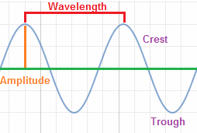
Figure 1: Identifying wavelengths using crests and troughs. From Wavelength definition, By Tutor Circle, 2018 (http://physics.tutorcircle.com/waves/wavelength.html). Copyright 2018 by Tutor Circle.

FREQUENCY: the number of waves created each second and is measured in hertz (Hz).
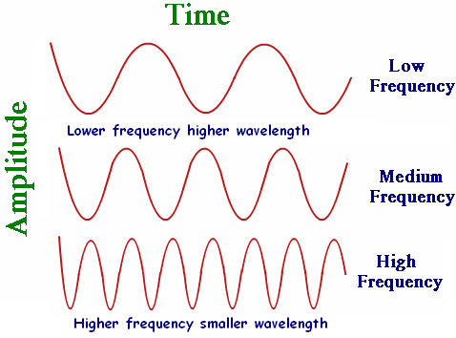
Figure 2: Relationship between frequency & wavelength. From How are frequency and wavelength related, by Tutor Circle, 2018 (http://physics.tutorcircle.com/waves/frequency-and-wavelength.html). Copyright 2018 by Tutor Circle.

Frequency, wavelength and speed work together in what is known as the wave equation to produce waves of different forms.
As all types of radiation travel at the speed of light (300,000km/s) the equation dictates that:
- When frequency of a wave increases, wavelength will decrease
- When frequency of a wave decrease, wavelength will increase

All electromagnetic waves do not require a medium in which to move and can travel through liquids, gases, empty space & some solids - high frequency/high energy radiation can pass through most solids, while low frequency/low energy radiation can be stopped by simple solids.

The Electromagnetic spectrum

The electromagnetic spectrum encompasses all radiation spanning a range of wavelengths and frequencies. As each radiation has a different set of properties –namely different energy levels- each radiation type can be applied in a different way to enhance our everyday life.
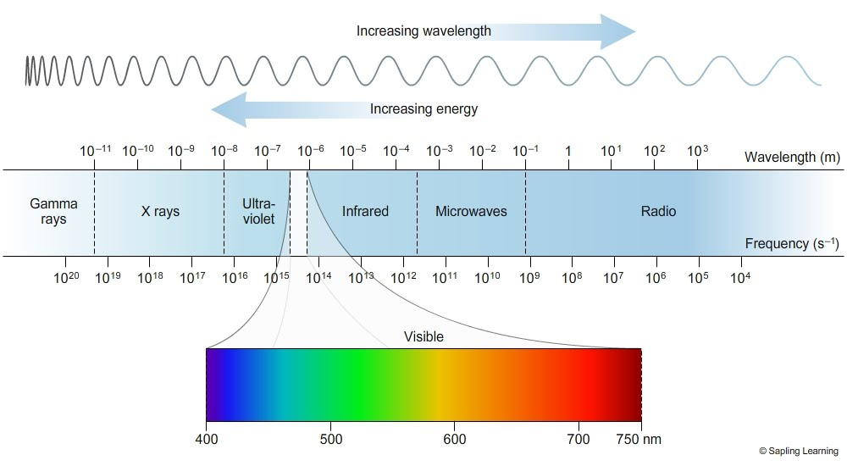

Figure 3: The electromagnetic spectrum. From EM spectrum, by Macmillan Learning, 2008 (https://sites.google.com/site/chempendix/em-spectrum). Copyright 2008 by Sapling Learning.

https://www.youtube.com/watch?v=uJ3ea9fa6CA&t=9s

Check out the electromagnetic radiation fact files below.

RADIO WAVES
Frequency: < 10⁹Hz
Wavelength: < 10⁻¹m
Application: radio waves are used in both radio and TV communications as they can travel extremely long distances. They work by vibrating antenna which is then converted into sound and/or images. While long radio waves bend around the surface of the earth, short radio waves are projected into the sky at an angle and is reflected back to earth upon hitting a layer of the atmosphere called the ionosphere. AM (30m wavelength) & FM (100m wavelength) radio work by combining radio waves with a carrier wave. Radio waves also play a part in wireless internet and mobile phone communication.

MICROWAVES
Frequency: 10⁹Hz- 10^{11.5}Hz
Wavelength: 10⁻¹m – 10^{-3.5m}
Application: Microwaves are used in both radar and communication systems utilised by people such as researchers or navy personnel. The most common use for microwaves is to heat and cook food using a metal microwave oven. The metal of the oven constantly reflects short microwaves (0.1mm wavelength) around the inside of the oven allowing them to be absorbed by sugars, water and fats within the food. This in turn causes the particles within the food to vibrate more and heat up. Note that the air surrounding the food, paper, glass and plastics remains unaffected by the microwaves - a plate or container being removed from the microwave may be hot only because the heat from the food has in part been transferred to it.

INFRARED
Frequency: 10^{11.5}Hz – 10^{14.2}Hz
Wavelength: 10^{-3.5}m – 10⁻⁶m
Application: As the sun is constantly emitting heat it produces infrared radiation which is then transferred to the earth in the form of sunlight. Any object that have temperature above absolute zero (-273ºC) will emit infrared radiation – yes that means humans do to! As most living creatures emit infrared radiation, specialised infrared cameras can be used to create a false colour images that aid in the locating, identifying and study of any living creatures especially during the night when visibility is low. Remote controls such as those that operate garage doors and DVD players also emit infrared radiation that is picked up by receivers within the reciprocal device.

VISIBLE LIGHT
Frequency: 10^{14.3}Hz – 10^{14.7}Hz
Wavelength: 10⁻⁶m – 10^{-6.5}m
Application: Visible light is one of three components of sunlight. The visible light spectrum consists of three primary colours – red, blue & green – which can combine to form three secondary colours – magenta, yellow & cyan. Humans interpret images in colour as each object will absorb some colours of the spectrum and reflect others. Visible light can also be polarised through a lens or filter to decrease glare and protect the eyes. Polarisation works by absorbing all but one plane of the visible light waves - A vertical filter will absorb horizontal and diagonal waves and allow vertical waves to pass through to be interpreted by the eye. Visible light is also required for the process of photosynthesis to occur in green plants.

ULTRAVIOLET
Frequency: 10^{14.7}Hz – 10^{16.2}Hz
Wavelength: 10^{-6.5}m – 10⁻⁸m
Application: Ultraviolet radiation is the third component of sunlight and is crucial in the production of vitamin D within humans. Small amounts of UV radiation can result in the skin darkening (tanning). However due to its high frequency and energy levels UV radiation can also be quite damaging if the skin or eyes are exposed for too long, resulting in burns, cancerous melanomas and cataracts. Sunglasses & sunscreen can be used as protective measures against UV radiation as they provide a layer of protection that either blocks or absorbs UV radiation. Some substances fluoresce when hit by UV radiation and it is this property that many companies have taken advantage of – for example the whitening process of teeth, paper & clothes, and the production of Australian currency. UV radiation can also be used as a high-grade steriliser because of its high frequency.

X-RAY
Frequency: 10^{16.2}Hz - 10^{19.3}Hz
Wavelength: 10⁻⁸m – 10⁻¹¹m
Application: X-rays are produced when fast moving electrons hit a metal sheet of tungsten. Due to their high energy and frequency, X-rays have high penetrating power which is commonly utilise for imaging purposes. X-rays travel more easily through less dense objects (eg. Skin) and dense objects (eg, bones) and as such a colour image is created based on the varying densities of the object. Both the medical profession (radiology, radiotherapy, CT scans) and security departments (baggage and package inspections) utilise X-ray machines to investigate the inner structure of an object without needing to physically open the object. While there are many practical uses for X-rays, they can be harmful as they have the potential to damage cells, tissue and even genetic material which is why protective lead shields are used and why minimal personnel can be near or operate the X-ray machine.

GAMMA RAY
Frequency: > 10^{19.3}Hz
Wavelength: > 10⁻¹¹ m
Application: Gamma rays operate at an extremely high frequency and energy level which allows them to interact with matter. This property allows gamma rays to be used in cancer radiotherapy as they free electrons from atoms making them ionized. Additionally, radioactive materials that produce gamma rays are used in position emission tomography (PET) scans which allow medical professionals to create a 3D image from which they can study the functionality of organs and body systems. Gamma rays are also utilised in the production of nuclear power and nuclear bombs because of their extremely high energy level.
What’s more, as gamma rays have high penetrating power they can be used to test metals for imperfections and weaknesses – note that gamma rays can only be stopped by a thick layer of lead.

TEST YOUR UNDERSTANDING

Activity 1: Mix & Match
Using the word bank provided, fill in the table below so that each radiation type is correctly matched to its properties and everyday application.

WORD BANK
- Ultraviolet
- TV/radio networks & communication
- > 10^{19.3}Hz / > 10⁻¹¹ m
- Heating/ cooking of food & radar communication
- Infrared
- Visible colour spectrum & polarised sunglasses
- 10^{14.7}Hz – 10^{16.2}Hz/ 10^{-6.5}m – 10⁻⁸m
- Investigate the structure of objects, radiology, radiotherapy & CT scans
- Radio waves
- 10^{14.3}Hz – 10^{14.7}Hz/ 10⁻⁶m – 10^{-6.5}m
- 10^{11.5}Hz – 10^{14.2}Hz/ 10^{-3.5}m – 10⁻⁶m
- Radiotherapy & diagnosing illness via PET scans
- Microwaves
- 10^{16.2}Hz - 10^{19.3}Hz/ 10⁻⁸m – 10⁻¹¹m

RADIATION | PROPERTIES | APPLICATION
X-Ray | 10^{16.2}Hz - 10^{19.3}Hz/ 10⁻⁸m – 10⁻¹¹m | Investigate the structure of objects, radiology, radiotherapy & CT scans
Infrared | 10^{11.5}Hz – 10^{14.2}Hz/ 10^{-3.5}m – 10⁻⁶m | Creates heat, Specialised cameras used for measurement of heat emission & remote controls
Radio waves | < 10⁹Hz  < 10⁻¹m | TV & radio networks, wireless internet & mobile phone communication
Gamma Ray | > 10^{19.3}Hz  > 10⁻¹¹ m | Radiotherapy, diagnosing illness via PET scans, nuclear power & testing for weaknesses in metals
Microwaves | 10⁹Hz- 10^{11.5}Hz  10⁻¹m – 10^{-3.5m} | Radar communications & Heating/cooking
Ultraviolet | 10^{14.7}Hz – 10^{16.2}Hz  10^{-6.5}m – 10⁻⁸m | Aids production of Vitamin D, sterilising agent, currency proofing & Whitening products
Visible light | 10^{14.3}Hz – 10^{14.7}Hz  10⁻⁶m – 10^{-6.5}m | Visible Colour spectrum, polarised sunglasses & photosynthesis

Activity 2: Crossword
Using the knowledge you have gained on the properties of waves & the electromagnetic spectrum, complete the crossword below.

- Radiation type between 400nm- 750nm (visible light)
- (Electromagnetism) a field of energy continually and simultaneously acted upon by both magnetic and electrical forces
- (frequency), the number of waves created each second
- (wavelength), the distance between two successive peaks in a wave
- (energy), Increased frequency means the waves have more ....
- (ionizing), gamma radiation is a form of ....... radiation
- (infrared) specialised cameras are used to create false colour images and measure heat signatures of this radiation
- (ultraviolet), some substances may fluoresce when hit with this radiation
- (density), what factor causes the different colour shades in images produced by an X-ray machine
- (transverse) electromagnetic waves are what kind of wave
- (Radiowaves) Radiation waves are reflected back toward the earth from the ionosphere and bend around the earth
- (microwaves) Radiation that is absorbed by sugar, water and fats causing the particles to vibrate more quickly and thus heat up.

ACTIVITY 3: Research
Using your knowledge of the types of radiation in the electromagnetic spectrum, choose one type of radiation and create a poster showcasing the advantages and disadvantages of this type of radiation.

You can utilise the internet, journal articles and/or resources suggested in this website to aid your research.

RESOURCES

The information found in this website was sourced from the following resources and can be utilised for further stage five science education.

Richards, G., Clarke, W., Devlin, J., Linstead, G., & Spenceley, M. (2014). Pearsons science New South Wales: Student book 9. Melbourne, VIC: Pearson Australia.

Sapling Learning. (2008). EM spectrum [Digital diagram]. Retrieved from https://sites.google.com/site/chempendix/em-spectrum

Tutor Circle. (2018). How are frequency and wavelength related [Digital diagram]. Retrieved from http://physics.tutorcircle.com/waves/frequency-and-wavelength.html

Tutor Circle. (2018). Wavelength definition [Digital diagram]. Retrieved from http://physics.tutorcircle.com/waves/wavelength.html

Warnant, P., Arena, P., Burrows, K., Lofts, G., & Evergreen, M. J. (2010). Core Science: Stage 5 complete course. Milton, QLD: John Wiley & Sons Australia

Whalley, K., Neville, C., Roberson, P., Rickard, G., Phillips, G., Jeffery, F., & Ellis, J. (2005). Science Focus 4. Melbourne VIC: Pearson Education Australia.

